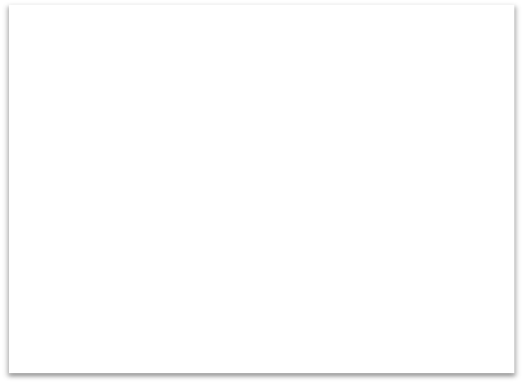

**As artists and musicians we will:**

* Explore printing techniques using The Great Wave Off Kanagawa

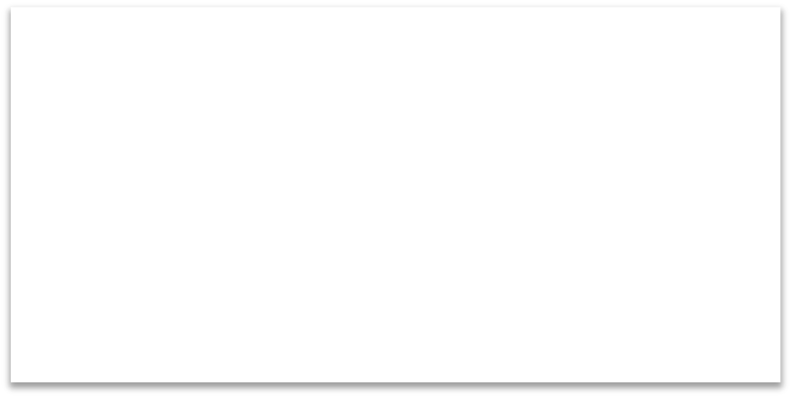

**As mathematicians we will:**

be developing mathematical confidence to use and apply concepts such as:

* Fractions
* Decimals
* Number and Place Value
* Multiplication
* Polygons and Coordinates



**To enrich our learning we will:**

Year 4 Spring Term 2

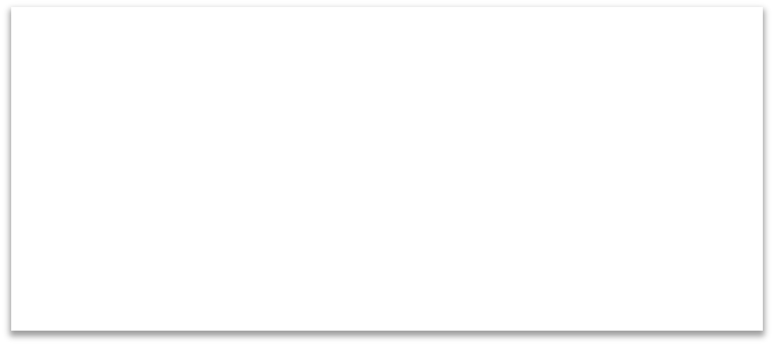

**As scientists and engineers we will:**

* Compare and group solids, liquids and gases.
* Observe reversible changes in materials during heating and cooling.
* Identify the part played by evaporation and condensation in the water cycle.
* Ask relevant questions and use scientific enquiry to answer them.
* Record findings using diagrams, bar charts and tables.

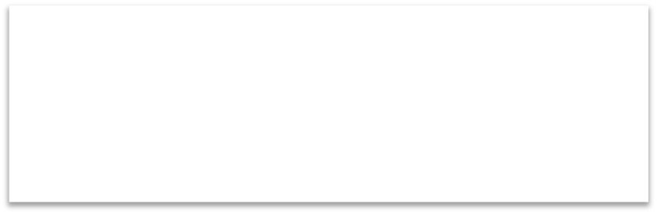

**As British citizens we will:**

* Consider how to maintain positive relationships, in line with our school values.
* Learn about founders and prophets from different religions.

States of Matter



**As readers and writers we will:**

Read and respond to Charlie and The Chocolate Factory by Roald Dahl.

We will write in a range of styles including:

- Imaginative description

- Letters

- Newspaper reports

- Narratives

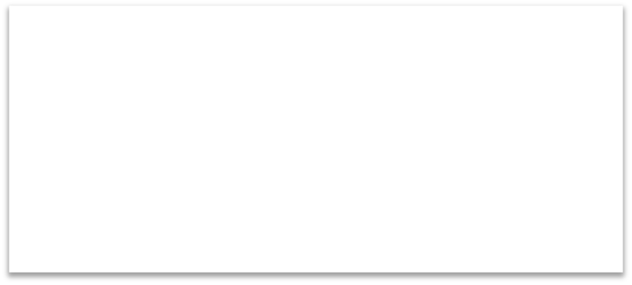

**As historians and geographers we will:**

* Describe and understand key aspects of rivers.
* Understand the water cycle.

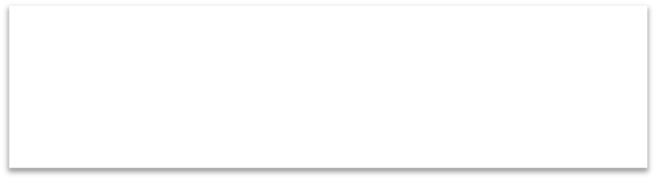

**As athletes we will:**

Develop our fitness and skills in the following:

- Football

- Dance