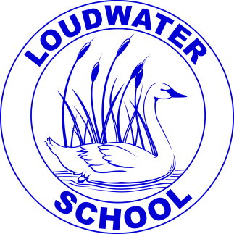 | Loudwater Combined School  Learn, Create, Succeed |  | School Way, Kingsmead Road
 |  |  | Loudwater, High Wycombe
 |  |  | Buckinghamshire, HP11 1JJ
 | Headteacher: |  | Tel: (01494) 524919
 | Mrs. Clare Cunnington |  | Fax: (01494) 538313
E-mail: office@loudwater.bucks.sch.uk
Website: www.loudwater.bucks.sch.uk
5th December 2016

Dear Parents,

On Friday it is our school and FOLS Christmas Bazaar. The children will be busy this week making items to sell at the Bazaar as part of our whole school enterprise week. FOLS will also be running a number of stalls including refreshments and a barbecue.

The classes are making:
Foundation Stage Christmas playdough ho ho!
Year 1 Rocking Robin decorations and biscuits
Year 2 Gingerbread reindeer biscuits
Year 3 Jazzy jars
Year 4 Painted pebbles
Year 5 Spiced Christmas biscuits and decorations
Year 6 Greetings cards and decorations

There will also be a second hand children’s book stall – any contributions to this can be brought to school during this week. There is a children’s cake competition on Friday morning with a prize for each class – we hope to sell the cakes at the Bazaar.

The Bazaar begins at 3.00pm on Friday so children will visit the range of stalls from this time. Parents are welcome to join us from 3.00pm onwards. However, if you are unable to get to school until normal pick-up time, please send your child with some money to spend in a named purse or envelope.

Children will be able to go home once they have finished looking around the Bazaar; however all children will need to be signed out by an adult before leaving. We ask that all parents enter school through the top Key Stage 1 gate and also leave by this gate. There will be space to leave any buggies just inside the gate.

We have spread the stalls out to avoid congestion in the hall:

- In the Foundation Stage classroom there will be the Foundation Stage stall, Year 1 and Year 2 and the children’s tombola.
- In the Year 3 classroom there will be the Year 3 stall, face painting, cake stall and the Guides stall.
- In the kitchen area there will be refreshments and snacks.
- In the hall there will be adult tombola, raffle, luck dip, second hand children’s book stall and the Year 4, 5 and 6 stalls.

Yours faithfully,

Clare Cunnington
Headteacher

