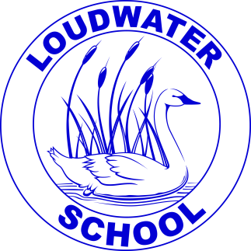 | Loudwater Combined School |  | School Way, Kingsmead Road
 |  |  | Loudwater, High Wycombe
 |  |  | Buckinghamshire, HP11 1JJ
 | Headteacher: |  | Tel: (01494) 524919
 | Mrs. Clare Cunnington
 |  |  | E-mail:office@loudwater.bucks.sch.uk
LOUDWATER NEWSLETTER
Friday June 22nd 2018

Dear Parents,

Important Calendar Dates
Sign up to continue receiving the newsletter on School Gateway
Tuesday 26th June - Whole School Legoland visit
Wednesday 27th June – Year 5 & 6 Girls Football Tournament
Thursday 28th June – Year 5 & 6 Cricket Tournament
Thursday 28th June - Values Assembly - Foundation Stage 9.00am
Friday 29th June - School Closed Training Day for teachers

News from the classes this week:
Foundation Stage
This week we have all enjoyed visiting the school's Art Exhibition and have admired the beautiful work there. We have been writing stories based on the book by Pat Hutchins, called "Rosie's Walk". We have been using pictures to practice our addition skills and in phonics we have been learning about four letter words that have a Consonant, Vowel, Consonant, Consonant (CVCC) pattern. You can practice this on the phonics play website.
https://www.phonicsplay.co.uk/Phase4Menu.htm

Year One
This week, in English, we have been focussing on poetry. We have loved the poem ‘Pants’ by Giles Andreae. It is very funny! We identified all the amazing adjectives that the poet used and also performed the poem with lots of actions. We wrote our own acrostic pants poems which we enjoyed sharing and we also wrote one as a class. We had a lot of fun writing adverts to try to persuade people to buy our favourite pairs of pants.
In Maths Year 1 has been finding 5 more and 5 less than numbers that are multiples of 5. We have also been counting purses full of 5ps. This week we have also had fun solving worded problems involving 5ps. We had to work out how much money was in each piggy bank and write the number sentences to match the problems.
In topic, Year 1 has been thinking about the types of clothes that they would wear in different seasons and the reasons why. We also looked at the world map and talked about the clothes we would wear if we lived close to the equator or far away from the equator.
Next week we are aiming to do some junk modelling. If you have any empty boxes please send them in with your child.
https://www.youtube.com/watch?v=Pchrn4a4V7c (our Pants poem)
http://www.ictgames.com/sharkNumbers/mobile/index.html (up to 99)

Year Two
In English, this week, Year 2 has been using the film text ‘Dangle’ to inspire our writing. We predicted the events of the story from listening to only the sound, we then wrote a persuasive letter to the man to tell him what he should do when he finds the rope, we also wrote a recount of the day from the man’s point of view and wrote a narrative to tell the story of what happened next! In Phonics, we have been revising the rule for using possessive apostrophes. In Maths, we revisited fractions. We have been finding fractions of a shape, learning equivalent fractions and scaling up and down by doubling and halving numbers. In Topic, we have learned about different types of transport from around the world. We learned their names and in which country they are used e.g. Tuk Tuk from Thailand. We have also considered the positive and negative aspects of everyday vehicles used in England. In addition, we enjoyed a visit to the Loudwater School Art Gallery, where we had the opportunity to view everyone’s work and write a review of one of the pieces of art.
http://www.bbc.co.uk/bitesize/ks1/maths/division/

Year Three
This week in English, Year 3 has been writing all about what life was like in the Stone Age. We started the week writing in small groups, thinking carefully about the structure of our stories. We then independently planned, wrote and edited our very own stories.
In Maths, we have been focusing on time. We discussed how many months there are in each year, how many days in each month and how many hours are in each day. We also discussed the difference between am and pm along with telling the time to the nearest 5 minutes using digital and analogue clocks.
We drew our own cave paintings in Topic this week and they looked fantastic! We enjoyed visiting the Art Exhibition and had the opportunity to write a note to the artist whose work we most enjoyed. We have also been practicing our singing for the school CD. We are very much looking forward to next week, being Science week, where we will be completing lots of investigations about magnets and forces!
http://www.bbc.co.uk/bitesize/ks2/science/physical_processes/magnets/read/1/

Year Four
In English this week, Year 4 has been writing a range of poetry based on the Ancient Egyptians. We have written haikus based on our knowledge of syllables; kennings using the style of a riddle poem to describe something from Ancient Egyptian times; and finally we have written acrostic poems using poetic devices. We have then published our poems and created a book of Year 4 Ancient Egyptian Poems.
In maths this week, we have been learning about decimals and fractions in real life. We have discussed where we might find fractions and decimals, e.g. to measure length and money. We have revisited equivalent fractions and found decimal equivalences to different fractions including a half, a quarter and three quarters. We have also begun to measure different items found in the classroom and record them using decimal notation.
In our topic lessons, we have written up research about the River Nile. This included how the Ancient Egyptians used the River Nile and how important it was to them. We then used our research to create a tourist information leaflet to try to persuade early settlers to move to live near the River Nile. Finally, we have begun learning about Ancient Egyptian family life.
http://www.historyforkids.net/egyptian-families.html

Year Five
This week in English, Year Five has edited and rewritten our flashback stories. We have also started to research and write non-chronological reports about World War Two to fit in with our work on ‘The Piano’. We have chosen different aspects such as food rationing, the role of women or the development of new weapons.
In maths this week, Year Five has been calculating the perimeter and area of rectilinear shapes. We have found missing side lengths and divided compound shapes into different rectangles in order to calculate more easily. We have also been outside to measure and calculate the perimeter and areas of different parts of the playground.
In topic lessons, Year Five has been investigating the effects of air resistance. We have designed and created running 'costumes' in order to use what we know about shape and surface area to slow a runner down. We had great fun doing this on the field on Thursday afternoon and came up with some very creative ideas!
http://www.bbc.co.uk/bitesize/ks2/science/physical_processes/forces/read/1/

Year Six
In English this week, we have watched a short film called ‘The Swing’. It is about a boy who suddenly discovers a small park area with a large tree and a swing attached to it. It looks very welcoming and before you know it he is enjoying himself, swinging backwards and forward as high as he can. But all is not as it seems as he soon finds out…. We have used the film to write a short story based on the clip. In Maths this week, we have started a Theme park investigation. We have been given £500,000 and have secured a plot of land. We have planned and designed our theme park, thinking about the types of rides, attractions and facilities a visitor would need. We have then used our plans to calculate the costs and income from running a theme park. Rehearsals for the Year 6 leavers Play – ‘Pirates of the Curry Bean’- have continued this week.
https://www.boxofideas.org/ideas/practical-skills-in-education/primary-school-2/transition-from-primary-to-secondary-school/

As you will see, we did not hold our usual Achievement Assembly this week due to our Art Week display in the hall.
Achievement Award Winners
 | Foundation Stage | Year 1 | Year 2 | Year 3 | Year 4 | Year 5 | Year 6
8.06.18 | Jack-Dean | Emily | Adna | Whole Class | Lexie | Eleanor | Sarah
15.06.18 | Breagha | Andreea | Chloe | Grace | Dominic | Miguel | Maya

The following children have been recognised in achievement assembly for their good behaviour:
 | Foundation Stage | Year 1 | Year 2 | Year 3 | Year 4 | Year 5 | Year 6
8.06.18 | Charlie Emily | Dexter Andreea | Lily  Lilly | Zachary Jacob | Ayaan A Teyha | Emy  Macy | Oscar Aadya
15.06.18 | Leo  Evan | Tyler Benjamin | Alacia Ticha | Gio  Lucy S | Riley  Sri | Breanna Louie | Aaron Maia

Attendance
 | Foundation Stage | Year One | Year Two | Year Three | Year Four | Year Five | Year Six
8.06.18 | 99% | 95% | 97% | 99% | 99% | 99% | 98%
15.06.18 | 94% | 97% | 100% | 98% | 99% | 96% | 99%
22.06.18 | 98% | 100% | 98% | 97% | 98% | 99% | 97%

Punctuality
Number of children arriving after 9.00am
 | Foundation Stage | Year One | Year Two | Year Three | Year Four | Year Five | Year Six
8.06.18 | 0 | 0 | 4 | 0 | 0 | 0 | 0
15.06.18 | 0 | 0 | 6 | 0 | 0 | 0 | 0
22.06.18 | 0 | 0 | 4 | 1 | 0 | 0 | 0

House points for this week
 | Elgar | Beethoven | Tchaikovsky | Mozart
8.06.18 | 244 | 307 | 239 | 269
15.06.18 & 22.06.18  combined | 436 | 355 | 391 | 423

General Data Protection Regulations (GDPR)
In line with the new GDPR requirements we now need your consent to enable us to continue sending out our weekly newsletter due to the fact that it does contain various sports and club activities from third parties, which may be construed as ‘Direct marketing’. This also includes requests for fund raising. Please therefore use the school gateway to register your consent which will allow us to continue sending out our informative weekly newsletter bringing you vital news, activities and school updates. Thank you in advance.

Whole School Legoland Visit
We are still waiting for a few Legoland trip consents. If you have not already visited the Gateway to give consent and make your contributions please do so as soon as possible. The cost for the visit to Legoland will be £15.00 if you have been paying in instalments please check that the full payment has now been made.

I know that all the children are greatly looking forward to the visit to Legoland on Tuesday. The weather forecast suggests that it will be a warm sunny day so can I please remind you of the following:
- Please apply sun cream in the morning and bring a sunhat to wear.
- Bring a refillable water bottle in addition to any drink for lunchtime.
- Ideally bring lunch in a back pack or similar bag that is easy to carry.
- Children should wear their school polo shirts and may wear shorts - non-uniform but of an appropriate length, not jeans or denim fabric.
- Please do not bring cameras or money.
- Will be leaving promptly so please make sure you arrive at school on time.
After School Clubs
As we expect the children to be very tired after the Legoland trip there will be no After School Clubs on Tuesday.

School Gateway
We have a number of items on the Gateway that require your attention.
- Sign up to continue receiving the newsletter
- Year 2 and KS 2 - Consent to wear goggles during swimming (if required).
- Whole School – CD Offer as outlined previously.
- Whole School – Consent to wear sunglasses (if required on medical grounds).
- Whole School – Consent and contribution Legoland trip.
- Year 4 Team Building Fun Day
- Year 3 & 4 PSHE Activities
Please remember to book your child onto the Breakfast Club register through the Gateway

Art Exhibition
Thank you to those of you who have taken the time to visit our amazing art exhibition this week. I am sure you will agree that all the work on display was of a very high quality and a great range of pieces inspired by different artists and artistic styles; further evidence of the talents of Loudwater pupils!
Thank –you to Miss Harris and all those who spent time preparing the children’s work for display and organising the exhibition.

Dolce Hot Meals
If you have already chosen your child’s meal for July 6th or July 12th please check to make sure that your order is correct. We have had an issue with children not having a lunch due to their order not being updated from hot meal to sandwich.

Sports Day and Race for Life
This year our school Sports Day will be held on Thursday 12th July.
You are welcome to join us for all or some of the day.
The programme of events (timings are approximate):
- From 9.15: Track races
- Followed by a carousel of events with children participating in house teams.
- From approximately 12.00 Picnic lunch on the field. Please bring a picnic lunch to share with your child/ren. If you are not able to stay to have lunch with your children they will be able to join their friends.
- From 1.30: Further activities which are non-competitive including the inflatables which have been provided by FOLS. During the afternoon we are also teaming up with Tesco to stage a “Race for Life” event to raise money for Cancer Research UK. This is an event just for children and there is no set distance they must run – we are just asking that they take part. To sponsor your child, and therefore raise money for the cause there is a Just Giving page for you to visit – https://fundraise.cancerresearchuk.org/page/loudwater-combined
If each child is sponsored for £2.50 this will enable us to reach our target of £500; however whatever you are able to donate will help this great cause.

On sports day, children should come to school in their PE kit. If they wish they may wear a t-shirt in the colours of their house:
- Mozart – yellow
- Beethoven – red
- Tchaikovsky – blue
- Elgar – green
Please make sure that your child has sun cream applied at home, brings a sun-hat and a water bottle. If the weather is particularly hot the programme may be revised to take account of this. Should it not be possible to hold sports day on Thursday 12th July our reserve day is Tuesday 17th July.

Our Year 4 ‘Word Cup’ team of the future
Team: James, Adam, Dominic, Jaiden, Ryan, Joshua, Thomas, Oliver

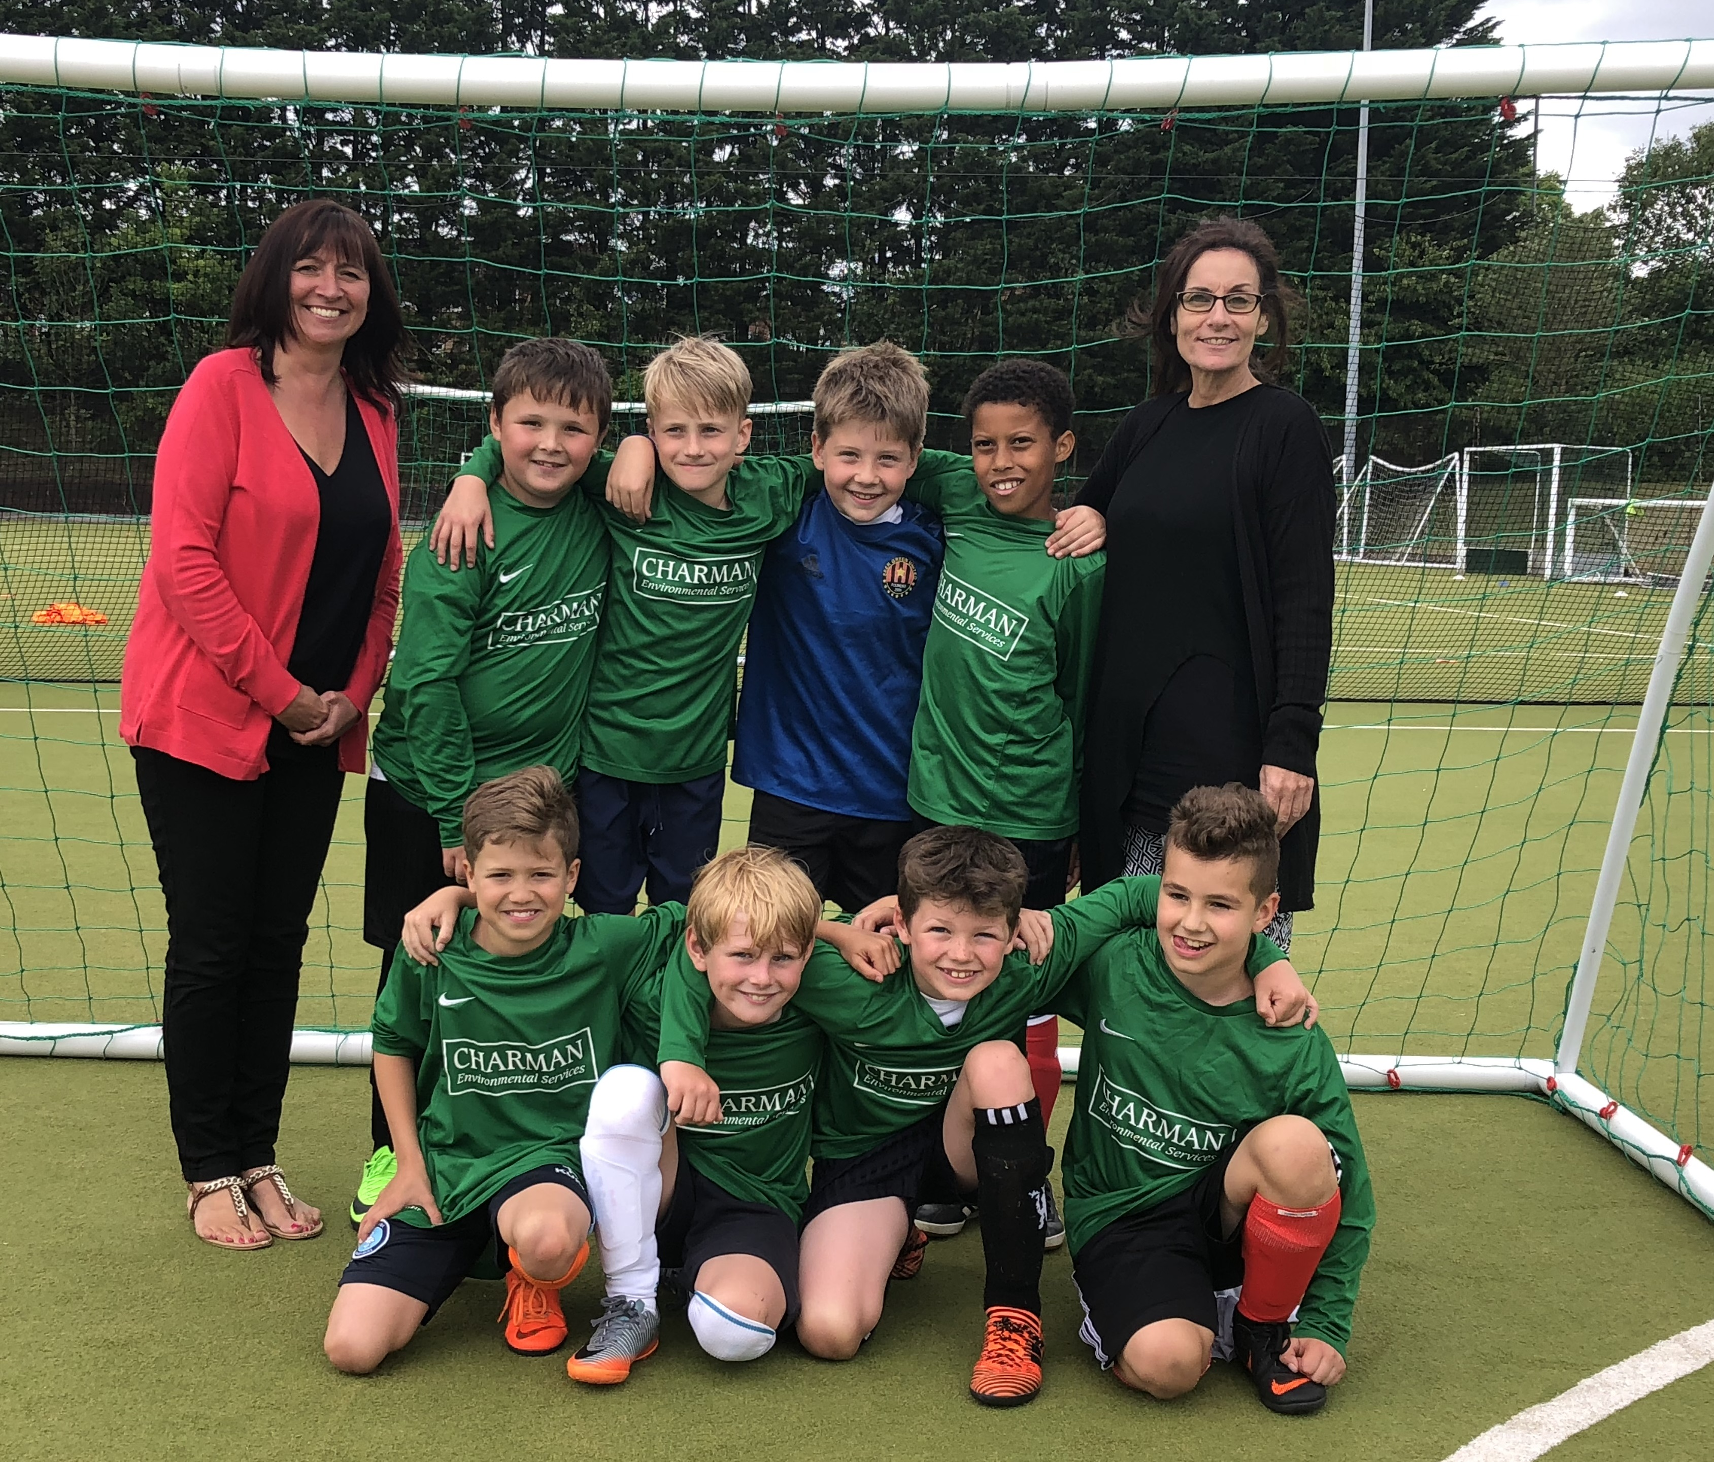

Year 4 Football Tournament

On Tuesday June 19th, our Year 4 boys took part in a football tournament at Cressex Astroturf against other schools from the local area. The boys played fantastically in their first round of matches, drawing the first game 0-0 then winning their second two games 5-0 and 1-0.
Progressing through to the second round of matches, Loudwater continued their good form with a 1-0 win in the first and drew their second and third matches both 0-0. To go the entire tournament without conceding a goal was a fantastic achievement! Loudwater finished 2nd overall out of 16 teams who had entered. Well done!

FRIENDS OF LOUDWATER SCHOOL
Ongoing information
Pantomime - This year’s pantomime at the Wycombe Swan is Snow White and the Seven Dwarfs. The date for your diary is Friday 14th December 2018 at 7pm. Tickets are priced at £21 each - we are now able to accept payment via debit/credit card along with cheque or cash. To reserve your tickets come and see us and collect a form. We will be back at the top of the hill every Friday morning. We will also be taking deposits and payments at the sports day event where there will also be forms available.
Summer Fete - Our annual summer fete is set for Saturday 14th July. This is our annual and most profitable fund raiser of the year but sadly is under threat of being scaled down or cancelled unless we have more volunteers come forward. We require volunteers to help organise, set up, help during the day and clear away. So, if you can label a jar, fold a ticket or sizzle a sausage please, please, please see a member of FOLS to put your name down.

Mufti day – Friday July 6th - Please bring in a bottle of something (could be wine, could be bubble bath) or a sweet for our Tombola stalls. Collection will beat the top of the hill from 8.15am.
Resellable Toys & Books – Wednesday July 4th - We are having a Toys, Books and Bric a Brac stall. If you have any items please bring them in on this date. Collection will be at the top of the hill from 8.15am.
Raffle/Auction – If you are able to donate a raffle or auction prize please contact a member of FOLS.
Cake competition – Friday July 13th - There will be a cake competition for each class. They can be big, small, biscuits, and scones, homemade or purchased! Due to storage and the weather please no fresh cream.
Secondary School places
If there are any parents of Year 6 pupils who do not yet have a secondary school place for their child in September, please contact school admissions – admissions@buckscc.gov.uk as a matter of urgency.

Yours faithfully

Clare Cunnington

Mrs C Cunnington
Head teacher

Newsletter
As you are aware we have moved to sending out our newsletter via email. Due to the GDPR, we are only able to continue sending out to those of you who have agreed so please do ensure that you register your consent on the gateway.

Disclaimer
From time to time we are asked by a range of organisations to give out leaflets. We always agree if we think this could be of interest or benefit to the children. However we do not endorse any of these organisations and parents should always check their credentials carefully to make sure children would be safe and well looked after.

LOUDWATER COMBINED SCHOOL
Calendar of events for 2017-18

June  26th Whole School Legoland visit  28th Values Assembly FS  29th School Closed Training Day for teachers | July  3rd Secondary School  Induction Day (Y6)  3rd New Parents Meeting  6th Annual Reports  12th Sports Day  12th Sandwiches from Dolce  14th Summer Fete  17th Reserve Sports Day  19th Values Assembly Y6  23rd 7.00pm Y6 Leavers Production  24th 9.30am Y6 Leavers Presentation Assembly  24th School closes at 2pm for summer break




