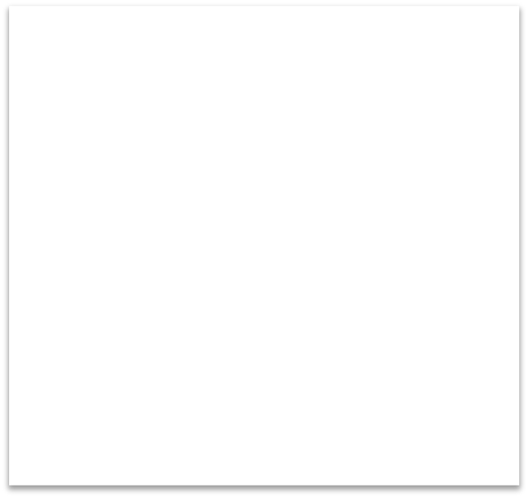

**As artists and musicians we will:**

* Learn how to create observational drawings, prints, photography and collages of habitats based on the work of Henri Rousseau.
* Practice singing and performance skills.
* Participate in a range of drama

activities.

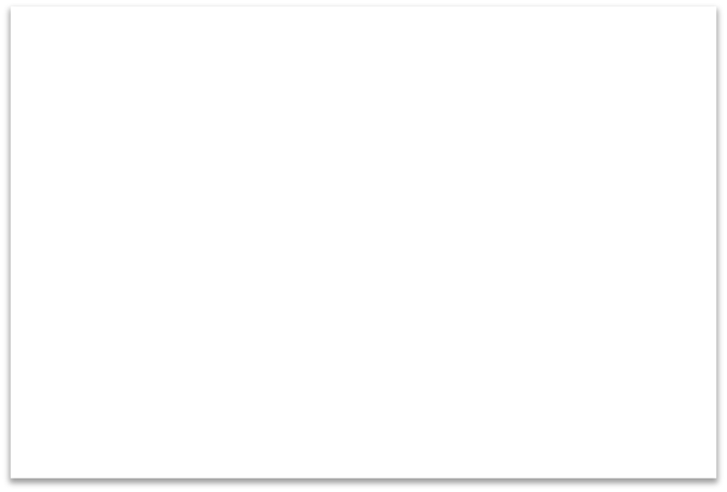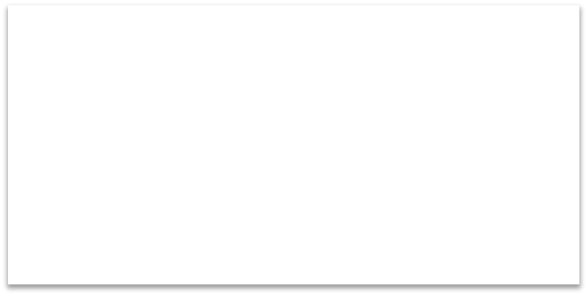

**As mathematicians we will:**

be developing mathematical confidence to use and apply concepts such as:

* Fractions
* Properties of shapes
* Time
* Addition
* Subtraction



**To enrich our learning we will:**

* Visit the school woodland and nearby habitats on the mead.

Year 2 Term 2: What a wonderful world!



**As athletes we will :**

Develop our fitness and skills in the following:

* The ugly bug ball dance unit
* Multi-skills led by Wycombe Wanderers.



**As British citizens we will:**

* To understand our values of responsibility, empathy, compassion and kindness.
* Learn about important people in our lives and in our communities, including religious leaders

.

**As geographers we will:**

* Use maps and atlases.
* Name continents and oceans of the world.
* Carry out fieldwork and observational studies.
* Name and describe physical and human features of the environment.

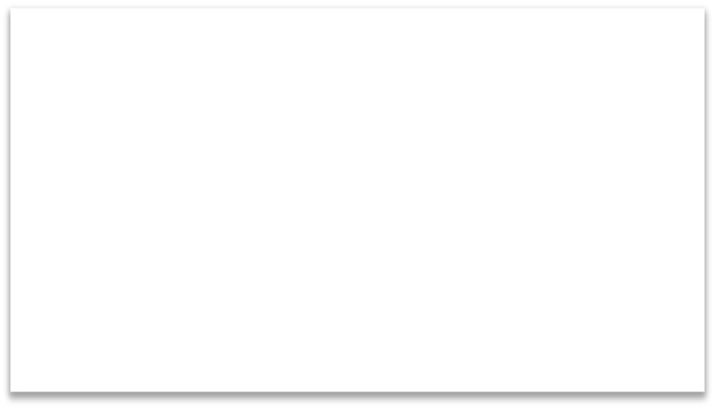

**As scientists and engineers we will:**

* Learn about micro and large habitats in the local environment and around the world.
* Learn how to make animal feeders or homes

.

* Develop our coding and programming skills.



**As readers and writers we will:**

Read and respond to poetry, Room on the broom by Julia Donaldson, Lost and Found by Oliver Jeffers and The Hodgeheg by Dick King-Smith.

We will write in a range of writing styles including:

* Poetry
* Persuasive writing/adverts
* Report writing/information texts
* Character study and description
* Letter writing
* Fiction writing - narratives
* Diary and recounts