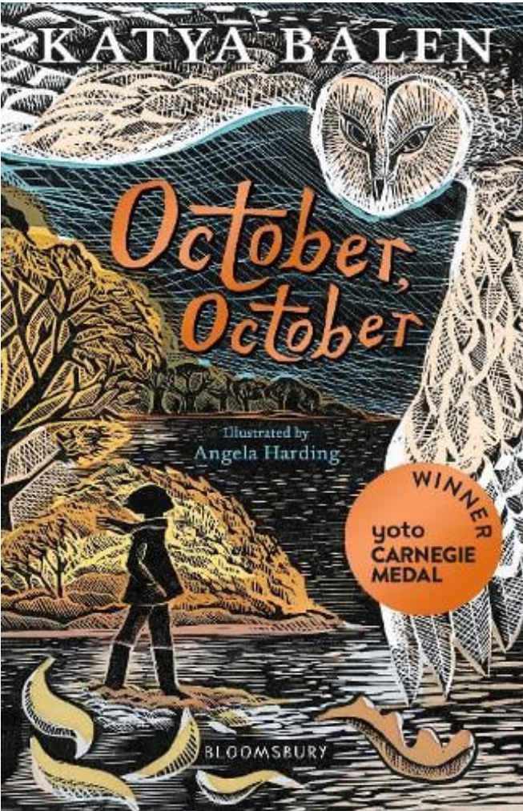

October, October by Katya Balen

October and her dad live in the woods. They have no TV, internet, mobile phone and no other electronic devices. They live a happy, simple life together in a wooden shack with wooden furniture where everything is home-made. They live off the land only buying the bare essentials. They pass their time gardening, building and drinking hot chocolate by an open fire, as October does not go to school.
When October was younger her mum decided she no longer wanted to live ‘wild’ in the woods, so she left October and her dad. October has not forgiven her mum for leaving them and refuses to see her, talk to her or read her letters.
One day, on her twelfth birthday, a tragic accident changes October’s life. She is forced to leave her wild life and join her mum in London. October has to adjust to living in a brick-built house in the city, going to school and using electronic devices. Her life is turned upside down.
Soon she makes a new friend, Yusef. October and Yusef have an interest in common – they both love finding treasures with stories to tell. Together, they join the River Thames Mudlarking club. October’s life becomes more bearable in London. But will she ever return to her wild life in the woods or will she be trapped in London for ever?

Recommended by Mrs Olcot

