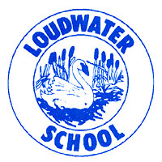 | Loudwater Combined School  Learn, Create, Succeed |  | School Way, Kingsmead Road
 |  |  | Loudwater, High Wycombe
 |  |  | Buckinghamshire, HP11 1JJ
 | Headteacher: |  | Tel: (01494) 524919
 | Mrs. Clare Cunnington |  | Fax: (01494) 538313
E-mail: office@loudwater.bucks.sch.uk
Website: www.loudwater.bucks.sch.uk
7.10.16

Dear Parents/Carers,

After half term Year 2 will be beginning a topic called ‘The Magic Toymaker’. To enhance the children’s learning and provide opportunities to be ‘hands on’ we have planned a trip to the Wycombe Museum where the children will have the opportunity to learn about old toys, play with toys from long ago and make an old toy of their own!

The visit will take place on Thursday 10th November. A coach will be collecting us at 9.30am and will bring us back to school for 2.30pm.

The children will require a packed lunch and a drink on this day. Please send the packed lunch and drink in a disposable bag. Most of the day will be indoors, but the children will need a waterproof coat for travelling to and from the museum. On the day the children will wear their school uniform and shoes as normal.

To cover the cost of the visit we are asking for a contribution of £7.50 per child. You can pay and give consent online using your School Gateway account. If you haven’t yet registered on School Gateway and would like more information, please contact the school office.

Yours sincerely,

Mrs Olcot

